81. Write a program in C to find the maximum and minimum elements in an array. Test Data : Input the number of elements to be stored in the array :3 Input 3 elements in the array : element - 0 : 45 element - 1 : 25 element - 2 : 21 Expected Output : Maximum element is : 45.

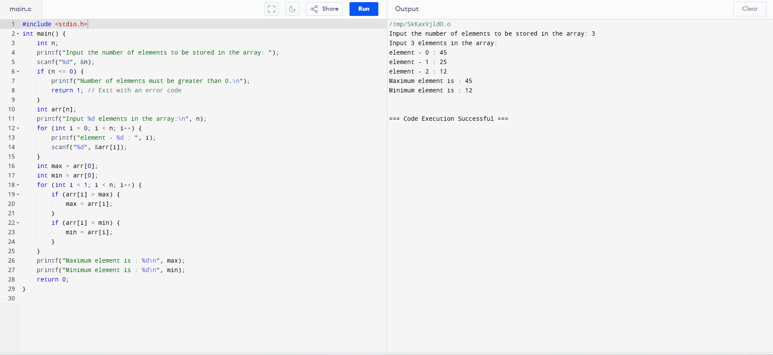

82. Write a C program to implement a queue using an array. Programs should contain functions for inserting elements into the queue, displaying queue elements, and checking whether the queue is empty or not. Expected Output: Initialize a queue! Check the queue is empty or not? Yes Insert some elements into the queue: Queue elements are: 1 2 3 Insert another element into the queue: Queue elements are: 1 2 3 4 Check the queue is empty or not? No.

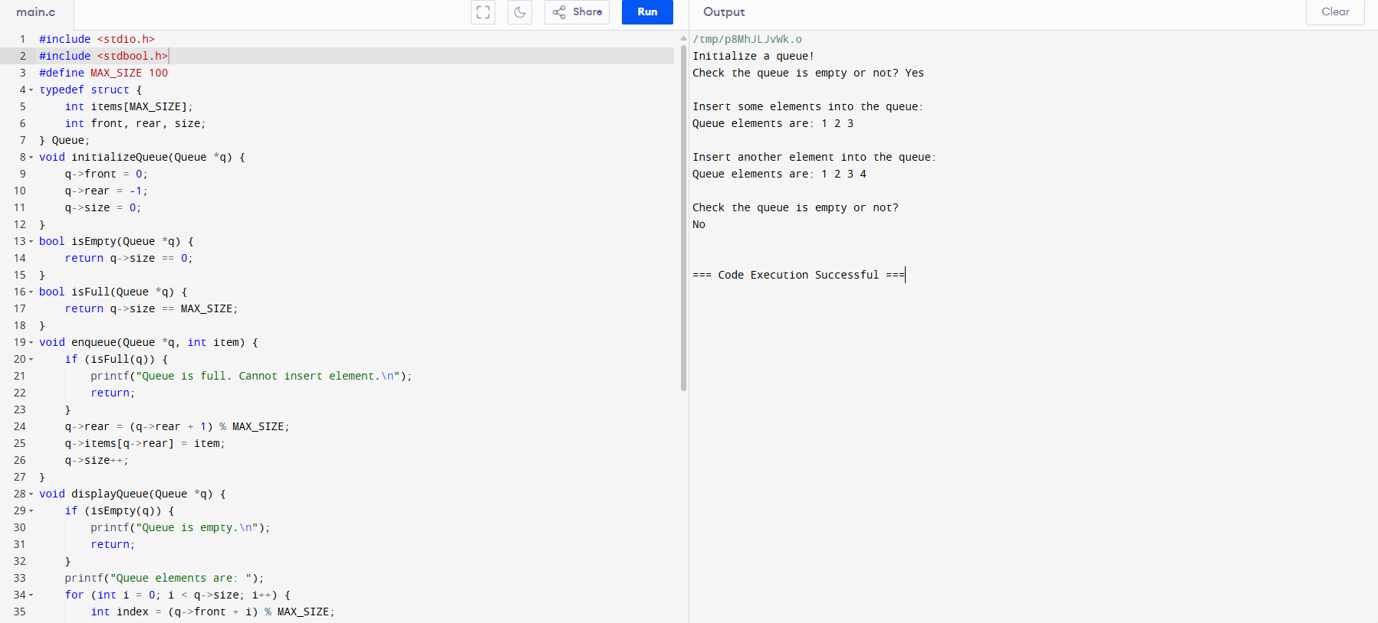

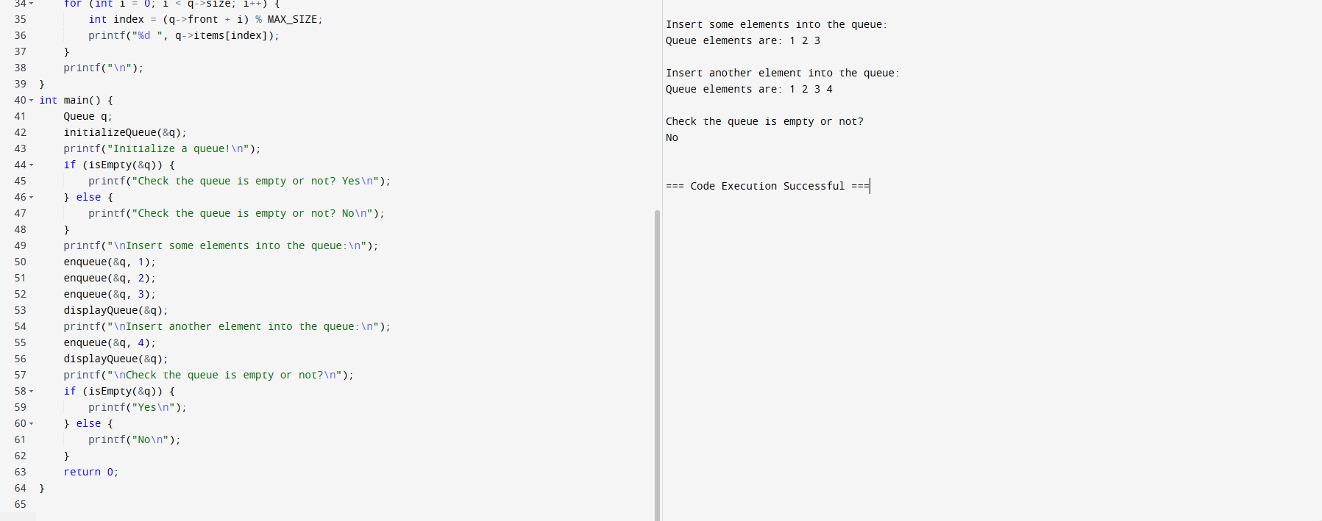

83. Write a C program to implement two stacks using a single array. > Expected Output: 3 popped from stack 1 2 popped from stack 1 1 popped from stack 1 30 popped from stack 2 20 popped from stack 2 10 popped from stack 2.

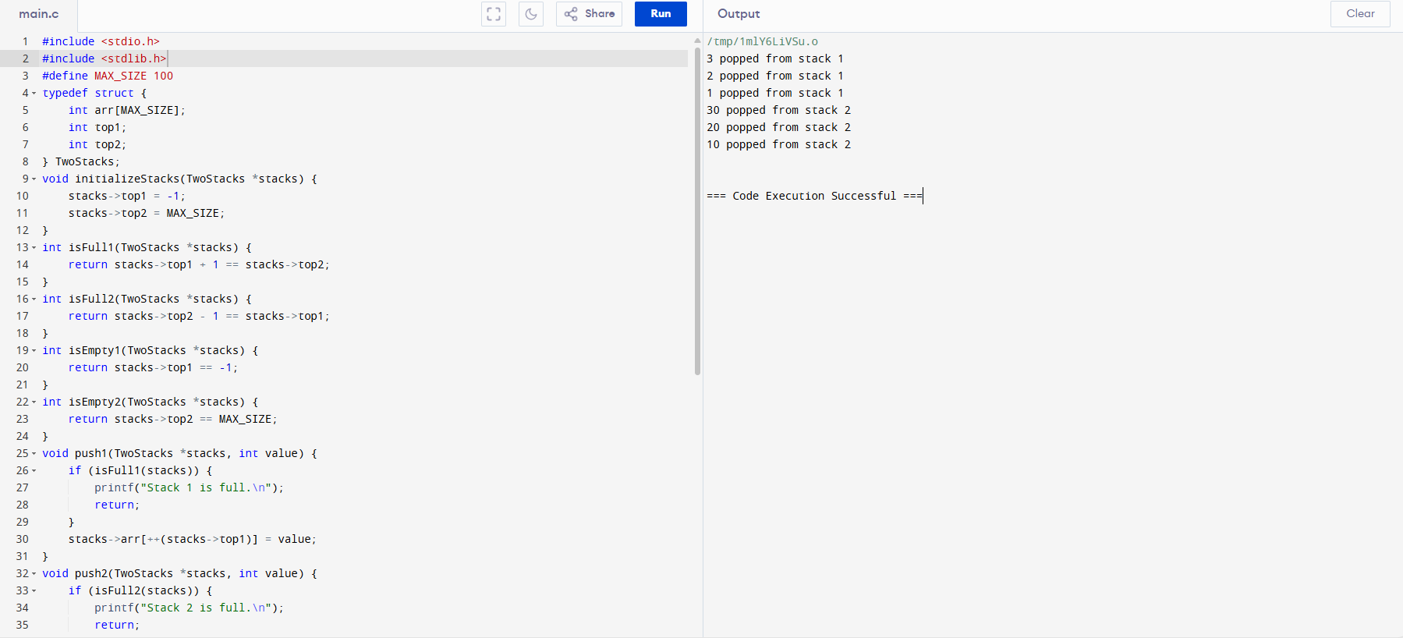

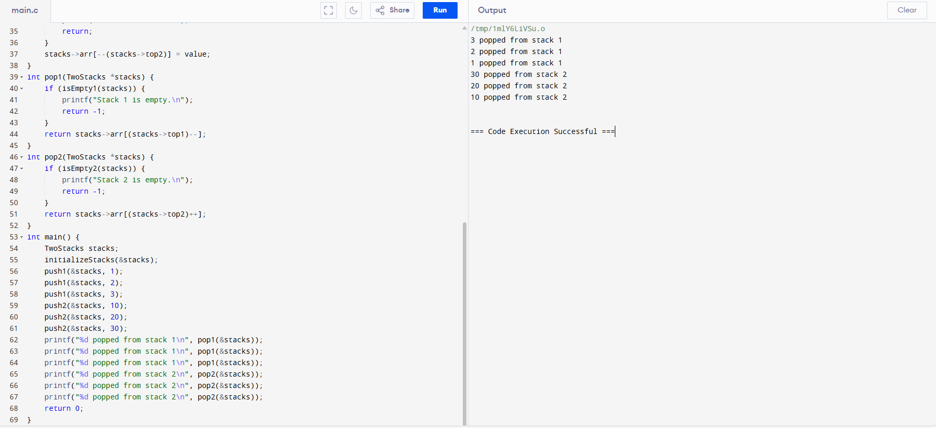

84. Write a program in C to separate odd and even integers into separate arrays. Test Data : Input the number of elements to be stored in the array :5 Input 5 elements in the array : element - 0 : 25 element - 1 : 47 element - 2 : 42 element - 3 : 56 element - 4 : 32 Expected Output : The Even elements are : 42 56 32 The Odd elements are : 25 47.

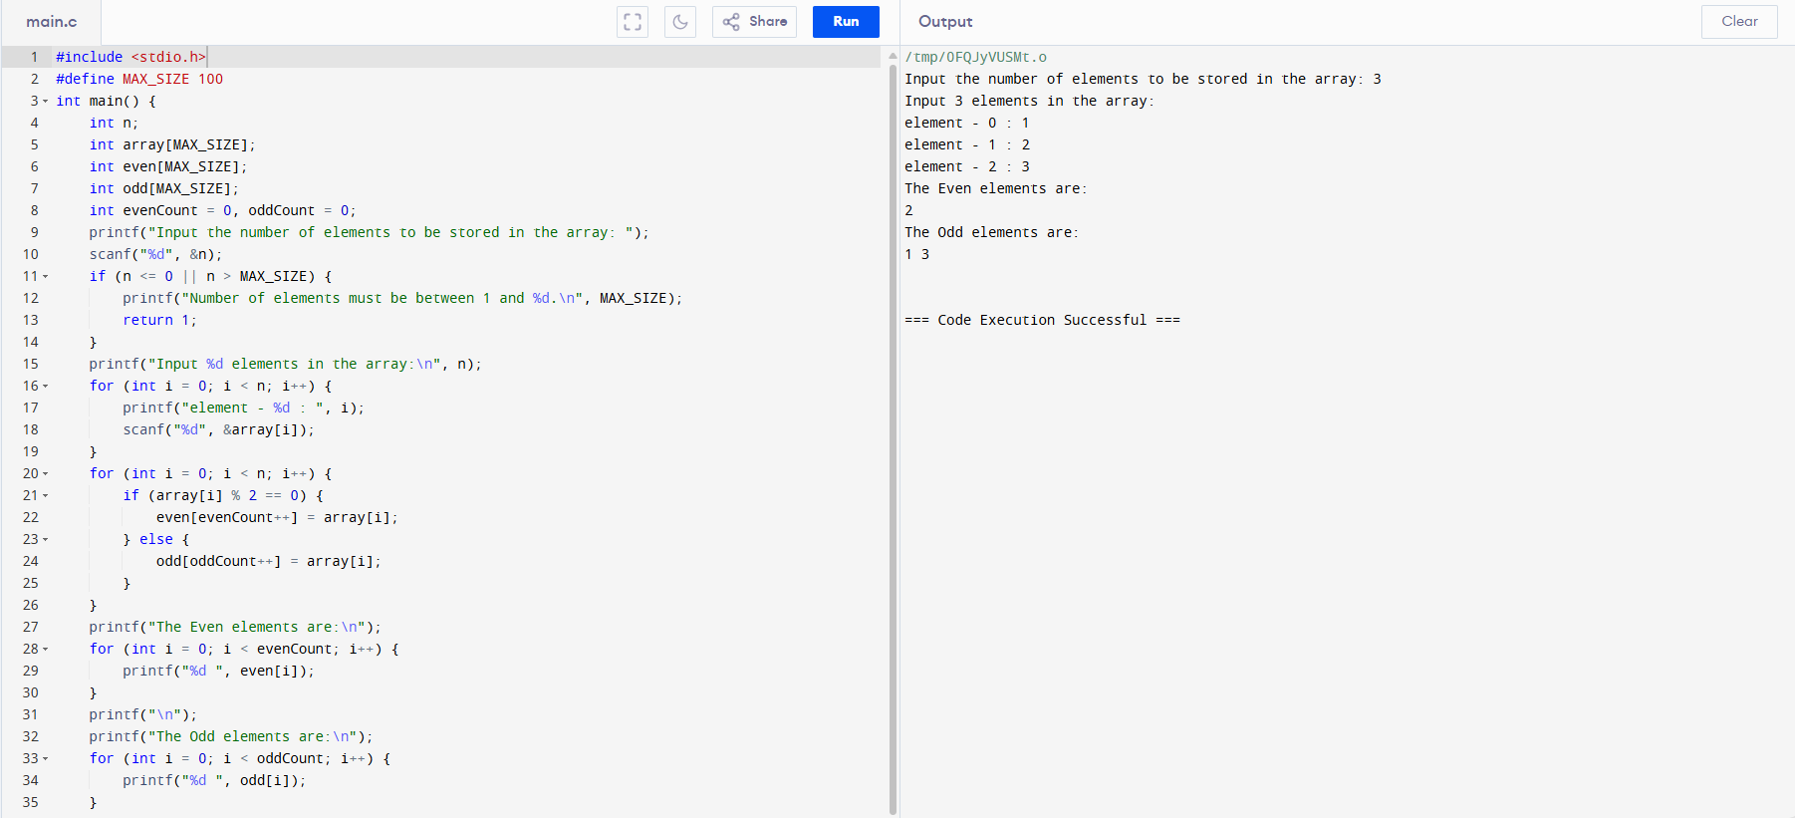



85. Write a C program to count the number of elements in a queue. > Expected Output: Initialize a queue! Check the queue is empty or not? Yes Number of elements in queue: 0 Insert some elements into the queue: Queue elements are: 1 2 3 Number of elements in queue: 3 Delete two elements from the said queue: Queue elements are: 3 Number of elements in queue: 1 Insert another element into the queue: Queue elements are: 3 4 Number of elements in the queue: 2.

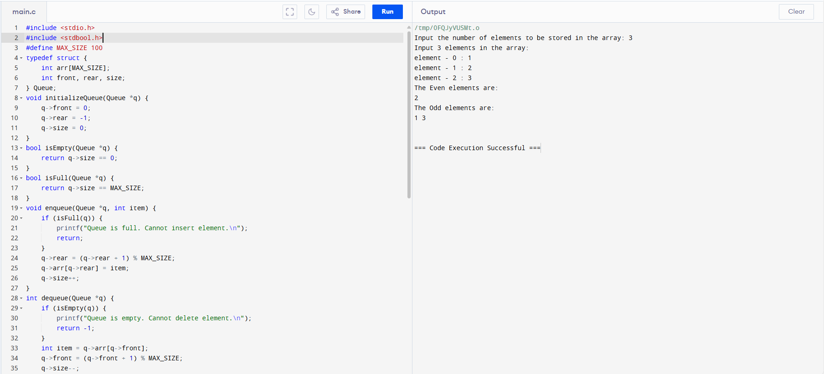

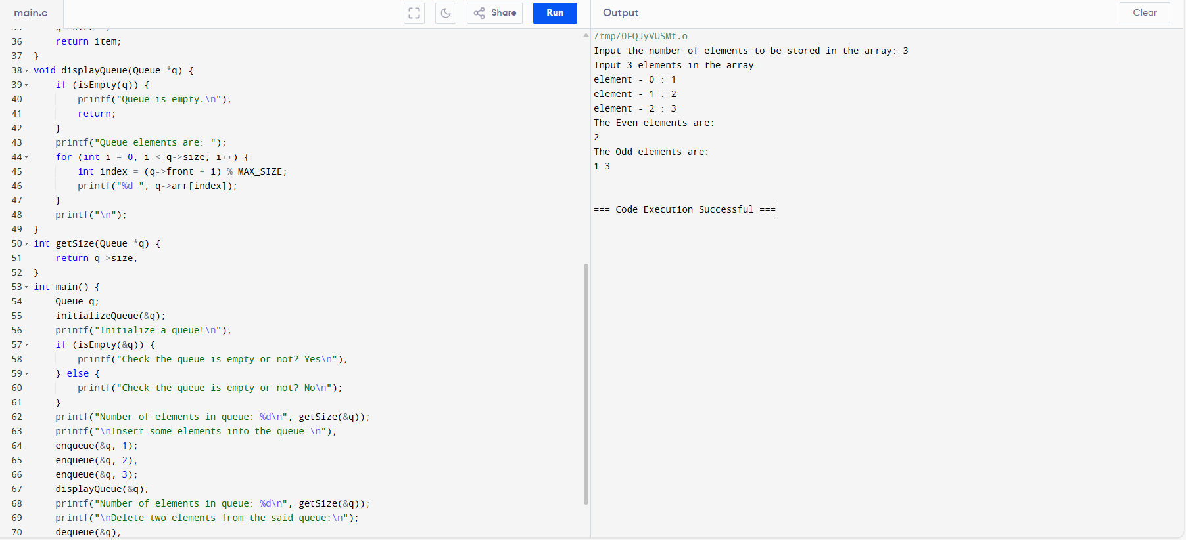

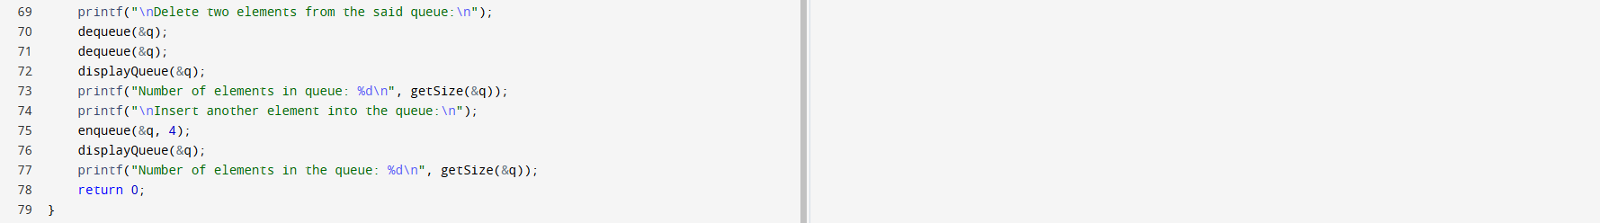

86. Write a C program to implement a stack and accept some numeric values. Find the top and kth element of the stack. > Expected Output: Elements of the stack: 1 2 3 4 5 6 Top element: 6 3rd element from top: 4 Remove the topmost element from the stack: Elements of the stack: 1 2 3 4 5 Top element: 5 4th element from top: 2.

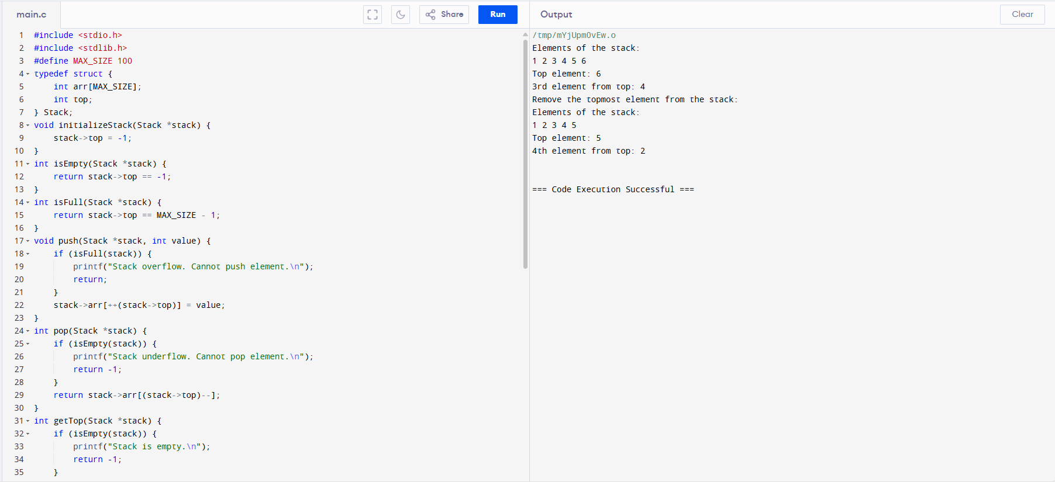

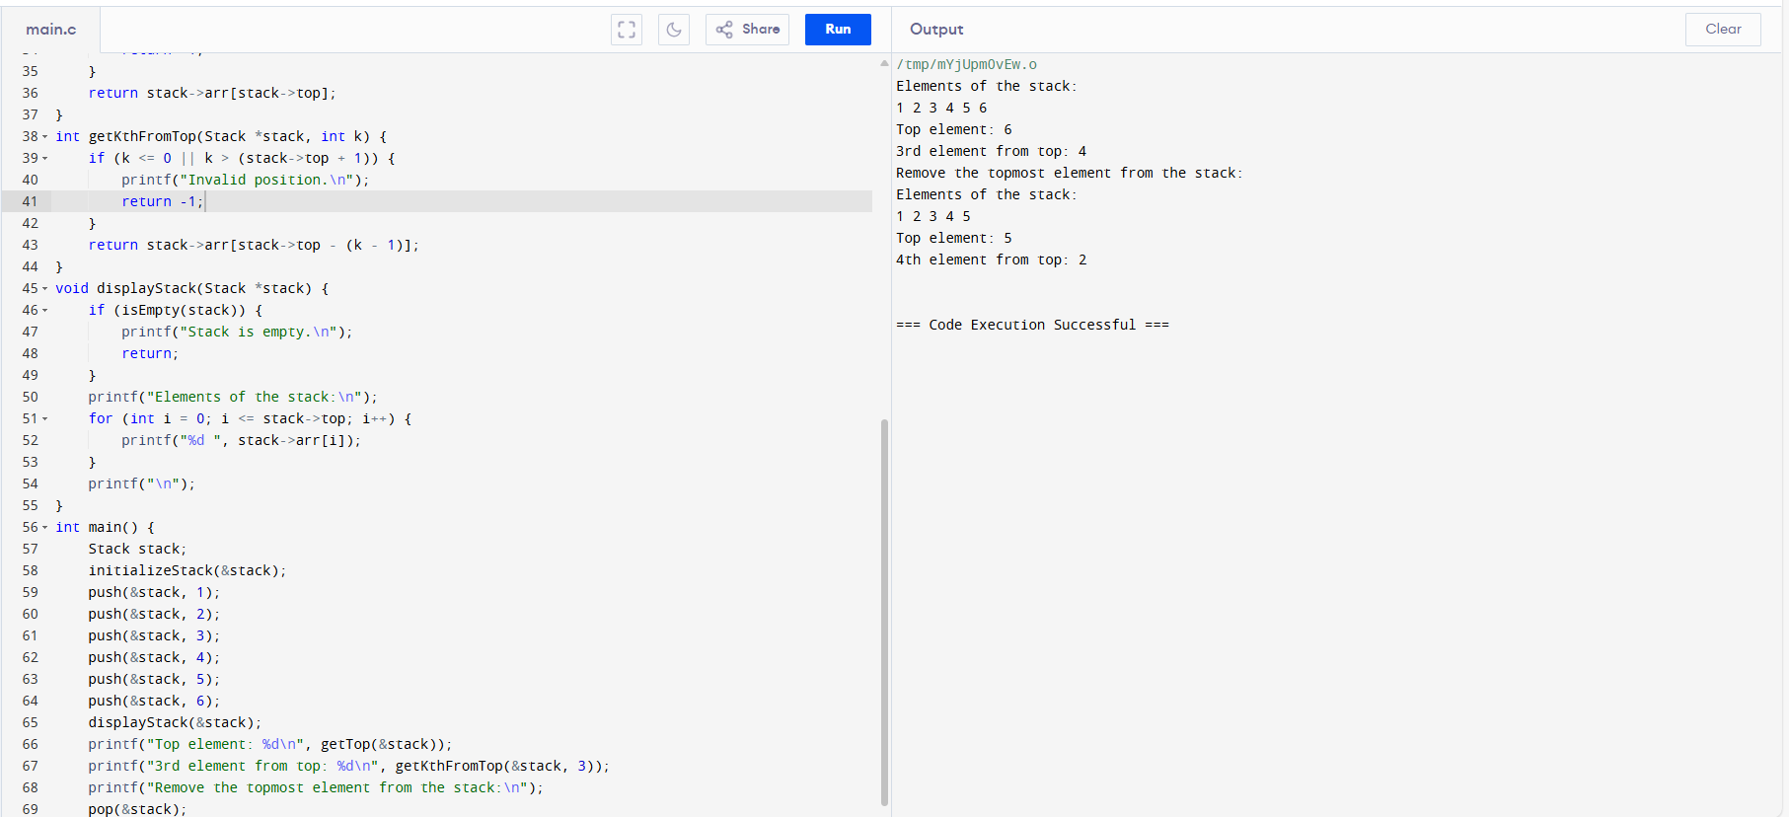



87. Write a program in C to sort elements of an array in ascending order. Test Data : Input the size of array : 5 Input 5 elements in the array : element - 0 : 2 element - 1 : 7 element - 2 : 4 element - 3 : 5 element - 4 : 9 Expected Output : Elements of array in sorted ascending order: 2 4 5 7 9.

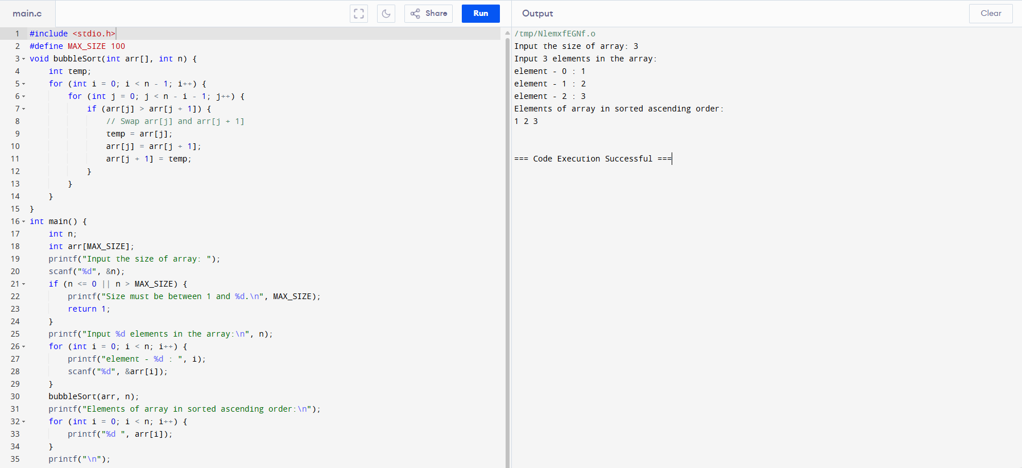



88. Write a program in C to sort the elements of the array in descending order. Test Data : Input the size of array : 3 Input 3 elements in the array : element - 0 : 5 element - 1 : 9 element - 2 : 1 Expected Output : Elements of the array in sorted descending order: 9 5 1.

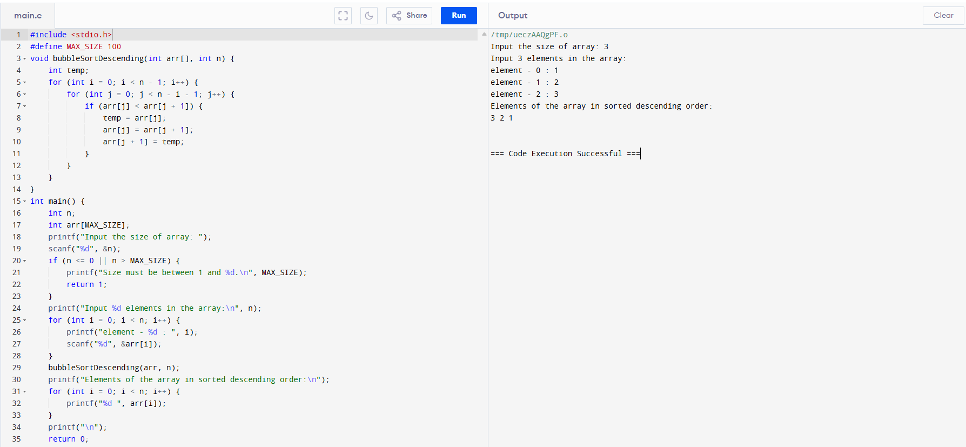

89. Write a program in C for a 2D array of size 3x3 and print the matrix. Test Data : Input elements in the matrix : element - [0],[0] : 1 element - [0],[1] : 2 element - [0],[2] : 3 element - [1],[0] : 4 element - [1],[1] : 5 element - [1],[2] : 6 element - [2],[0] : 7 element - [2],[1] : 8 element - [2],[2] : 9 Expected Output : The matrix is : 1 2 3 4 5 6 7 8 9.

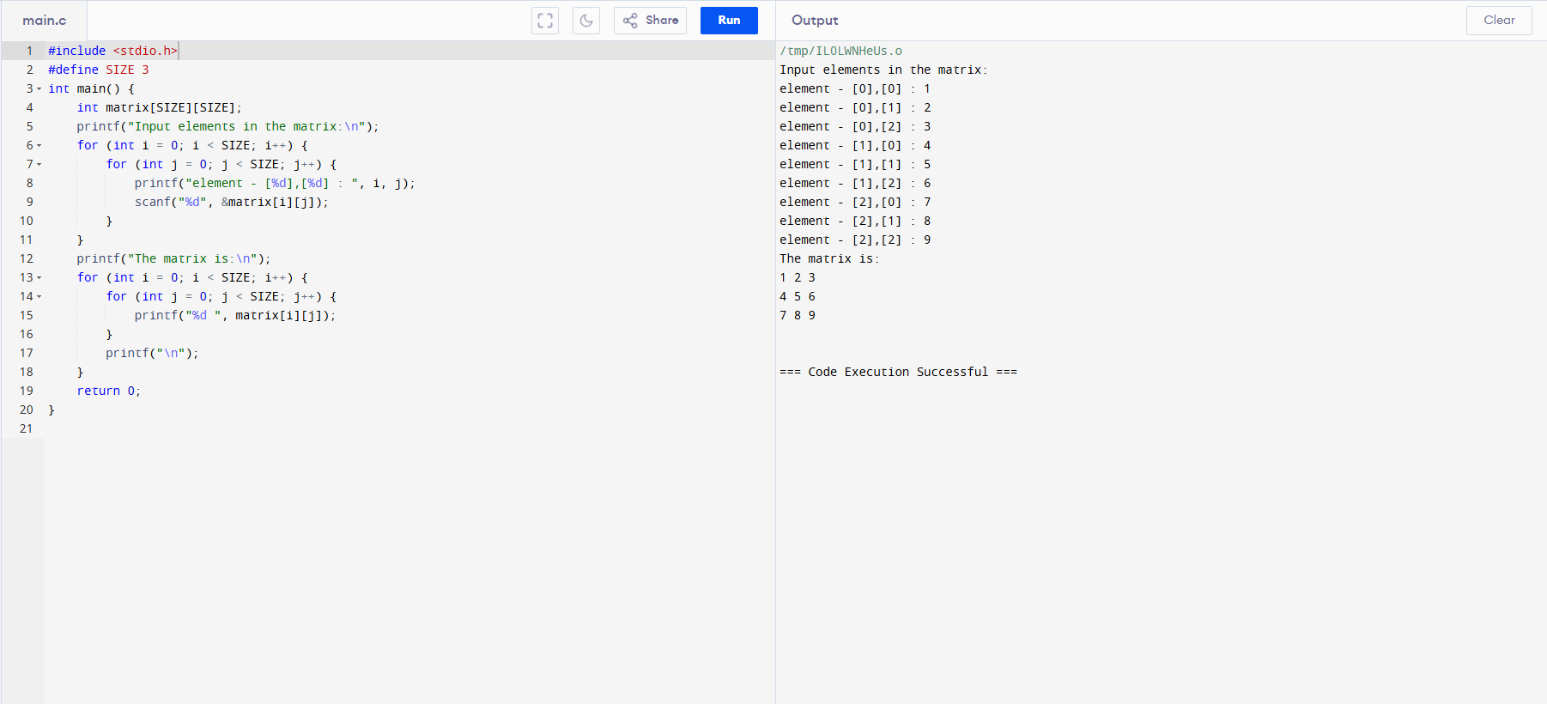

90. Write a program in C for adding two matrices of the same size. Test Data : Input the size of the square matrix (less than 5): 2 Input elements in the first matrix : element - [0],[0] : 1 element - [0],[1] : 2 element - [1],[0] : 3 element - [1],[1] : 4 Input elements in the second matrix : element - [0],[0] : 5 element - [0],[1] : 6 element - [1],[0] : 7 element - [1],[1] : 8 Expected Output : The First matrix is : 1 2 3 4 The Second matrix is : 5 6 7 8 The Addition of two matrix is : 6 8 10 12.

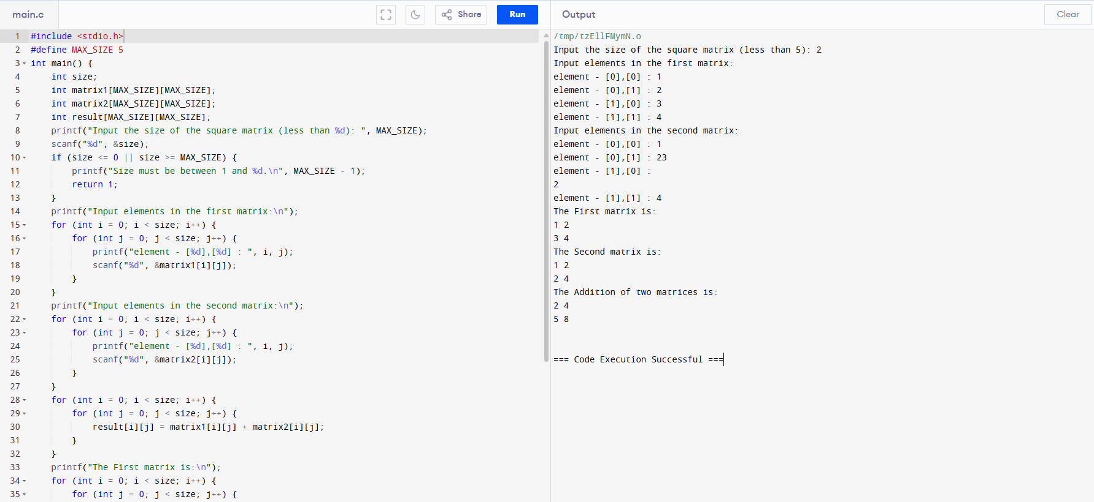

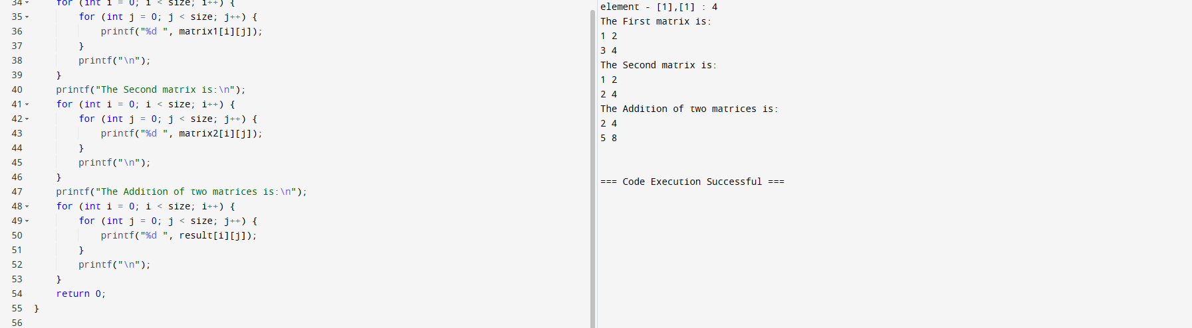

91. Write a program in C to find the sum of rows and columns of a matrix. Test Data : Input the size of the square matrix : 2 Input elements in the first matrix : element - [0],[0] : 5 element - [0],[1] : 6 element - [1],[0] : 7 element - [1],[1] : 8 Expected Output : The First matrix is : The matrix is : 5 6 7 8 The sum or rows and columns of the matrix is : 5 6 11 7 8 15 12 14.

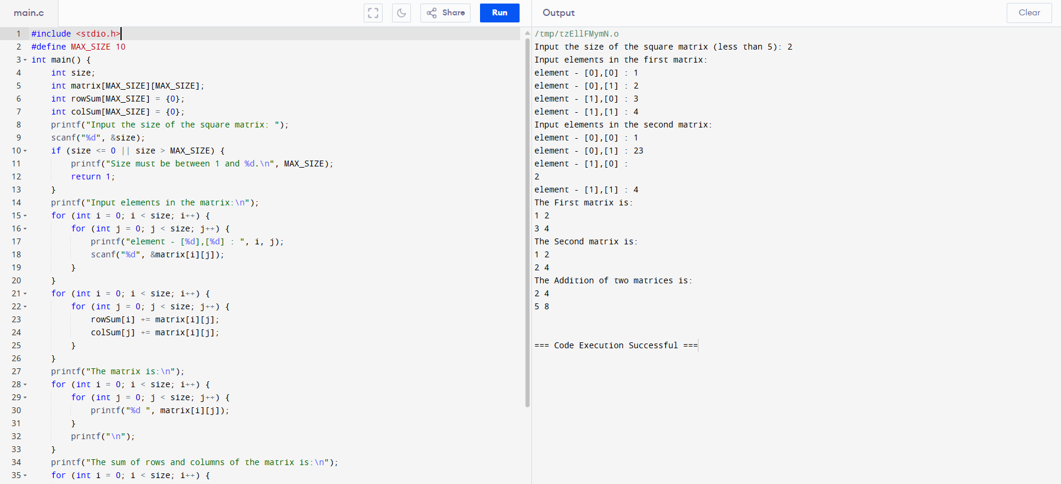

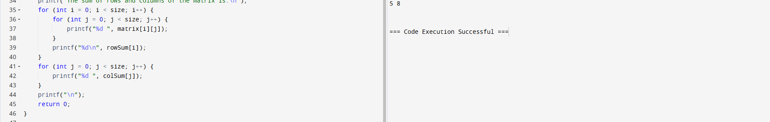

92. . Write a C program to find the maximum element in a queue. > Expected Output: Queue elements are: 1 2 3 4 5 Maximum value in the queue is: 5 Remove 2 elements from the said queue: Queue elements are: 3 4 5 Maximum value in the queue is: 5 Insert 3 more elements: Queue elements are: 3 4 5 600 427 519 Maximum value in the queue is: 600.

